**VISOKA TEHNIČKA ŠKOLA**

**STRUKOVNIH STUDIJA**

**S** **U B O T I C A**

**PROJEKAT**

**iz predmeta Elektronsko poslovanje**

**i**

**E - mobil aplikacije**

**KANDIDATI MENTOR**

**Branko Sabo dr Zlatko Čović**

**Miloš Jovanić Žaki**

**_____________________________________________________________________**

**SUBOTICA 2020. god.**

Sadržaj

**OPIS ZADATKA** 3

REALIZACIJA ZADATKA 3

STRUKTURA BAZE PODATAKA 10

OPIS FUNKCIONALNOSTI 10

KORIŠĆENA LITERATURA 14

# **OPIS ZADATKA**

Zadatak je bio da se napravi veb sajt, kao i mobilna aplikacija za predmete Elektronsko poslovanje I E-mobil aplikacije. Mi smo odlučili da to bude sajt koji se bavi prodajom wallpaper - a, koji smo nazvali WallpaperMe. Od tehnologija koristili smo HTML, CSS, PHP, JS, Bootstrap framework.

# REALIZACIJA ZADATKA

**Admin deo projekta**

**Index.php stranica**

*<?php require* "../includes/db_config.php" ;  
*session_start*();  
*if* (*isset*($_SESSION['admin'])) {  
 *if*($_SESSION['admin'] == 0 || $_SESSION['admin'] == 1) {  
 *header*("Location: ../index.php");  
 }  
} *else* {  
 *header*("Location: ../index.php");  
}  
*?>*<!doctype *html*>  
<html *lang*="en">  
<head>  
 <meta *charset*="UTF-8">  
 <meta *name*="viewport"  
 <link *rel*="stylesheet" *href*="../css/bootstrap.css">  
 <link *rel*="stylesheet" *href*="../css/bootstrap.min.css">  
 <title>Admin</title>  
</head>  
<body>>  
<nav *class*="navbar navbar-expand navbar-dark bg-primary">  
 <ul *class*="navbar-nav">  
 <li *class*="nav-item">  
 <a *class*="nav-link" *href*="../index.php">Početna</a>  
 </li>  
 <li>  
 <a *class* = "nav-link" *href*="listWallpapers.php">List Wallpapers</a>  
 </li>  
 <li>  
 <a *class* = "nav-link" *href*="listUsers.php">List Users</a>  
 </li>  
 </ul>  
</nav>  
</body>  
*<?php  
if*(*isset*($_GET['error'])){  
 $error = $_GET['error'];  
 *if*($error === 'success')  
 *echo* "<h4 class=\"text-center text-success mt-3\">Action completed successfully</h4>";  
}

ListUsers.php stranica u admin delu

*<?php  
require* "../includes/db_config.php";  
*if* (*isset*($_SESSION['admin'])) {  
 *if*(($_SESSION['admin'] == 0) *or* ($_SESSION['admin'] == 1)) {  
 *header*("Location: ../index.php");  
 }  
} *else* {  
 *header*("Location: ../index.php");  
}  
$sql = "SELECT *\** FROM user ORDER BY id_user DESC ";  
$query = *mysqli_query* ($conn,$sql);  
*?>*<!doctype *html*>  
<html *lang*="en">  
<head>  
 <meta *charset*="UTF-8">  
 <meta *name*="viewport"  
 <link *rel*="stylesheet" *href*="../css/bootstrap.css">  
 <link *rel*="stylesheet" *href*="../css/bootstrap.min.css">  
 <title>Admin | Users</title>  
</head>  
<nav *class*="navbar navbar-expand navbar-dark bg-primary">  
 <ul *class*="navbar-nav">  
 <li *class*="nav-item">  
 <a *class*="nav-link" *href*="../index.php">Početna</a>  
 </li>  
 <li>  
 <a *class* = "nav-link" *href*="listWallpapers.php">List Wallpapers</a>  
 </li>  
 <li>  
 <a *class* = "nav-link" *href*="listUsers.php">List Users</a>  
 </li>  
 </ul>  
</nav>  
<div *class*="container mt-5">  
 *<?php  
 while*($result = *mysqli_fetch_assoc*($query)){  
 $sql2 ="SELECT *COUNT*(*\**) as downloads_count FROM user_downloads as ud   
 JOIN wallpaper as w ON ud.id_wallpaper = w.id_wallpaper  
 WHERE w.id_user = {$result['id_user']} GROUP BY ud.id_user";  
 $query2 = *mysqli_query* ($conn,$sql2);  
 $row = *mysqli_fetch_row*($query2);  
 *echo*"  
 <div class=\"row\">  
 <div class=\"col-sm-4 col-md-12 col-lg-4\">  
 <form method=\"post\" action=\"deleteUsers.php\">  
 </div>  
 <div class=\"col-sm-8 col-md-6 col-lg-8\">  
 <strong>Uploader: </strong>{$result['username']}<br>  
 <strong>Email: </strong>{$result['email']}<br>  
 <strong>Power level (0-2): </strong>{$result['power']}<br>  
 <strong>Number of downloads: </strong>{$row[0]}<br>  
 <input type=\"hidden\" name=\"id\" value=\"{$result['id_user']}\" >  
 <button class=\"btn btn-primary mt-3\" name=\"delete\">DELETE</button>  
 </form>  
 </div>  
 </div>  
 <hr>  
";  
 }  
 *?>*</div>

**listWallpapers.php stranica u admin delu**

*<?php  
require* "../includes/db_config.php";  
*if* (*isset*($_SESSION['admin'])) {  
 *if*(($_SESSION['admin'] == 0) *or* ($_SESSION['admin'] == 1)) {  
 *header*("Location: ../index.php");  
 }  
} *else* {  
 *header*("Location: ../index.php");  
}  
$sql = "SELECT *\** FROM wallpaper w JOIN user u ON w.id_user = u.id_user ORDER BY id_wallpaper DESC ";  
$query = *mysqli_query* ($conn,$sql);  
*?>*<!doctype *html*>  
<html *lang*="en">  
<head>  
 <meta *charset*="UTF-8">  
 <meta *name*="viewport"  
 <link *rel*="stylesheet" *href*="../css/bootstrap.css">  
 <link *rel*="stylesheet" *href*="../css/bootstrap.min.css">  
 <title>Admin | Wallpapers</title>  
</head>  
<nav *class*="navbar navbar-expand navbar-dark bg-primary">  
 <ul *class*="navbar-nav">  
 <li *class*="nav-item">  
 <a *class*="nav-link" *href*="../index.php">Početna</a>  
 </li>  
 <li>  
 <a *class* = "nav-link" *href*="listWallpapers.php">List Wallpapers</a>  
 </li>  
 <li>  
 <a *class* = "nav-link" *href*="listUsers.php">List Users</a>  
 </li>  
 </ul>  
</nav>  
  
<div *class*="container mt-5">  
 *<?php  
  
// while($result = mysqli_fetch_assoc($query)){  
// $name = $result['desktop'];  
// $altName = explode (".",$name); // izracunavanje broja downloada  
// $sql2 ="SELECT COUNT(*) as downloads_count FROM user_downloads as ud  
// JOIN wallpaper as w ON ud.id_wallpaper = w.id_wallpaper  
// WHERE w.id_user = {$result['id_user']} GROUP BY ud.id_wallpaper";  
// $query2 = mysqli_query ($conn,$sql2);  
// $row = mysqli_fetch_row($query2);  
 while*($result = *mysqli_fetch_assoc*($query)){  
 $name = $result['desktop'];  
 $altName = *explode* (".",$name); *// izracunavanje broja downloada* $sql2 ="SELECT *COUNT*(*\**) as downloads_count FROM user_downloads as ud   
 JOIN wallpaper as w ON ud.id_wallpaper = w.id_wallpaper  
 WHERE w.id_user = {$result['id_user']} GROUP BY ud.id_wallpaper";  
 $query2 = *mysqli_query* ($conn,$sql2);  
 $row = *mysqli_fetch_row*($query2);  
 *echo*"  
 <div class=\"row\">  
 <div class=\"col-sm-4 col-md-12 col-lg-4\">  
 <form method=\"post\" action=\"deleteWallpapers.php\">  
 <img src=\"../images/{$result['desktop']}\" alt=\"$altName[0]\" width=\"332\" height=\"332\"><br>  
 </div>  
 <div class=\"col-sm-8 col-md-6 col-lg-8\">  
 <strong>Title: </strong>{$result['title']}<br>  
 <strong>Uploader: </strong>{$result['username']}<br>  
 <strong>Number of downloads: </strong>{$row[0]}<br>  
 <input type=\"hidden\" name=\"id\" value=\"{$result['id_wallpaper']}\" >  
 <button class=\"btn btn-primary mt-3\" name=\"delete\">DELETE</button>  
 </form>  
 </div>  
 </div>  
 <hr>  
";  
 }  
 *?>*</div>

**Watermark.php koji se koristi za stavljanje vodenog žiga na slike**

*<?php  
function* watermark($name, $ext){  
$source = "./images";  
$destination = "./destination";  
$watermark = *imagecreatefrompng*("watermark.png");  
*// $name= "5e24cf35507b92.29181249.png"; $ext= "png";*$margin_right = 10;  
$margine_bottom = 10;  
  
$sx = *imagesx*($watermark);  
$sy = *imagesy*($watermark);  
  
*//$images = array_diff(scandir($source), array('..','.'));  
  
//foreach ( $images as $image){  
 if*($ext=="jpg"||$ext=="jpeg"){  
 $img = *imagecreatefromjpeg*($source.'/'.$name);  
 }*elseif*($ext=="png"){  
 $img = *imagecreatefrompng*($source.'/'.$name);  
 }  
   
  
 *imagecopy*($img, $watermark, *imagesx*($img)-$sx-$margin_right, *imagesy*($img)-$sy-$margine_bottom,0,0,$sx,$sy);  
 $i = *imagepng*($img, $destination.'/'.$name, 100);  
 *imagedestroy*($img);  
*//}  
header*("Location: index.php?watermarked");  
}  
*// echo '<img src="./destination/'.$name.'">';  
?>*

**listUserWallpapers.php koji pokazuje wallpapere trenutnog usera**

<!DOCTYPE *html*>  
*<?php  
require* "includes/db_config.php";  
*require* "./verify.php";  
*session_start*();  
*?>*<html *lang*="en">  
<head>  
 <meta *charset*="UTF-8">  
 <meta *name*="viewport" *content*="width=device-width, initial-scale=1.0">  
 <meta *http-equiv*="X-UA-Compatible" *content*="ie=edge">  
 <link *rel*="stylesheet" *href*="./css/index.css">  
 <link *rel*="stylesheet" *href*="./node_modules/@yaireo/tagify/dist/tagify.css">  
 *<!-- Font Awesome -->* <link *rel*="stylesheet" *href*="https://use.fontawesome.com/releases/v5.8.2/css/all.css">  
 *<!-- Bootstrap core CSS -->* <link *href*="https://cdnjs.cloudflare.com/ajax/libs/twitter-bootstrap/4.3.1/css/bootstrap.min.css" *rel*="stylesheet">  
 *<!-- Material Design Bootstrap -->* <link *href*="https://cdnjs.cloudflare.com/ajax/libs/mdbootstrap/4.10.1/css/mdb.min.css" *rel*="stylesheet">  
 <title>WallPapersPlease</title>  
</head>  
<body>  
<div *class*="container">  
 *<?php  
 if*(*isset*($_GET['error'])){  
 $error = $_GET['error'];  
 *if*($error === 'success')  
 *echo* "<h4 class=\"text-center text-success mt-3\">Action completed successfully</h4>";  
 }  
 *//var_dump($_SESSION);  
 if*(!*isset*($_SESSION['id_user'])){  
 *echo* "  
<button type=\"button\" class=\"btn btn-primary\" data-toggle=\"modal\" data-target=\"#exampleModalLong\">  
 Login  
</button>";  
 }  
 *else*{  
 *include* "./downloads_count.php";  
 *echo*"  
 <a class=\"btn btn-primary\" href=\"./imageupload.php\">Upload</a>  
 <a class=\"btn btn-primary\" href=\"./index.php\">Search</a>  
 <a class=\"btn btn-primary\" href=\"logout.php\">Logout</a>";  
 }  
 $user = $_SESSION['id_user'];  
  
  
 $sql = "SELECT *\** FROM wallpaper w JOIN user u ON w.id_user = u.id_user WHERE w.id_user = '$user' ORDER BY id_wallpaper DESC ";  
 $query = *mysqli_query* ($conn,$sql);  
 *while*($result = *mysqli_fetch_assoc*($query)) {  
 $name = $result['desktop'];  
 $altName = *explode*(".", $name); *// izracunavanje broja downloada  
// $sql2 = "SELECT COUNT(*) as downloads_count FROM user_downloads as ud  
// JOIN wallpaper as w ON ud.id_wallpaper = w.id_wallpaper  
// WHERE w.id_user = {$result['id_user']} GROUP BY ud.id_wallpaper";* $sql2 = "SELECT *COUNT*(*\**) as downloads_count, ud.id_wallpaper, w.title   
 FROM user_downloads as ud  
 JOIN wallpaper as w ON ud.id_wallpaper = w.id_wallpaper  
 WHERE w.id_user = {$_SESSION['id_user']} AND w.id_wallpaper = {$result['id_wallpaper']} GROUP BY ud.id_wallpaper";  
 $query2 = *mysqli_query*($conn, $sql2);  
  
 $row = *mysqli_fetch_row*($query2);  
  
 *echo* "  
 <div class=\"row\">  
 <div class=\"col-sm-4 col-md-12 col-lg-4\">  
 <form method=\"post\" action=\"updateUserWallpapers.php\">  
 <img src=\"images/{$result['desktop']}\" alt=\"$altName[0]\" width=\"332\" height=\"332\"><br>  
 </div>  
 <div class=\"col-sm-8 col-md-6 col-lg-8\">  
 <input type='hidden' name='title' value='{$result['title']}'><strong>Title: </strong>{$result['title']}<br>  
 <strong>Uploader: </strong>{$result['username']}<br>  
 <strong>Number of downloads: </strong>{$row[0]}<br>  
 <input type=\"hidden\" name=\"id\" value=\"{$result['id_wallpaper']}\" >  
 <button class=\"btn btn-primary mt-3\" name=\"update\">UPDATE</button>  
 <button class=\"btn btn-primary mt-3\" name=\"delete\">DELETE</button>  
 </form>  
 </div>  
 </div>  
 <hr>  
";  
 }  
 *?>*

**Images.php preko kojeg se pretražuju slike iz baze**

*<?php  
// include "includes\db_config.php";  
  
 if*(*isset*($_GET['search'])){  
 *// $search = $_GET['search'];* $search = *trim*(*strtolower*($_GET['search']));  
 *//var_dump($search);  
 //$result= mysqli_query($conn, "SELECT * FROM `wallpaper` WHERE `tags` = '$search'"); exact* $result= *mysqli_query*($conn, "SELECT *\** FROM `wallpaper` WHERE `tags` LIKE '$search'");*//similar  
 //var_dump($result);  
 if*(*mysqli_num_rows*($result)>0){  
   
 *echo* "<div class=\"container\"><div class=\"row\">";  
 *while*($row = *mysqli_fetch_array*($result)){  
   
 $loc = $row['desktop'];  
 $name= $row['title'];  
 *// $v = $row['verified'];  
 if* ($row['verified']){  
 *echo* "<div class=\"col-4 border text-center\"><img class=\"img-fluid img-thumbnail\" src=\"./destination/$loc\" alt=\"$name\">";  
 *if* (*isset*($_SESSION['id_user']) && $_SESSION['sub'] == 1) {  
 *echo* "<a href=\"download.php?file=$loc\" class=\"track_click\" data-user-id=".$_SESSION['id_user']." data-wallpaper-id=".$row['id_wallpaper'].">download $name</a>";  
 }  
 *echo* "</div>";  
 }  
 }  
   
 *echo* "</div></div>";  
 }  
 *else*{  
 *echo* "<div class=\"container\"><div class=\"row\">";  
 *echo* "<div class=\"col-12 text-center\"<p>0 results found</p></div>";  
 *echo* "</div></div>";   
 }  
}  
 *?>*

**Downloads_count.php koji računa broj downloada određenog wallpapera**

*<?php  
  
require_once* "includes/db_config.php";  
  
$wallpaper = [];  
  
$sql = <<<SQL  
SELECT *COUNT*(*\**) as downloads_count, ud.id_wallpaper, w.title FROM user_downloads as ud  
JOIN wallpaper as w ON ud.id_wallpaper = w.id_wallpaper  
WHERE w.id_user = {$_SESSION['id_user']} GROUP BY ud.id_wallpaper  
SQL;  
$result= *mysqli_query*($conn,$sql);  
  
*while*($row = *mysqli_fetch_array*($result)){  
 $wallpaper[] = [ 'title' =>$row['title'], 'wallpaper_id' =>$row['id_wallpaper'], 'downloads_count' =>$row['downloads_count'] ];  
}  
  
  
  
  
$sql = "SELECT *COUNT*(*\**) as downloads_count, ud.id_wallpaper, w.title FROM user_downloads as ud  
JOIN wallpaper as w ON ud.id_wallpaper = w.id_wallpaper  
WHERE w.id_user = {$_SESSION['id_user']} GROUP BY ud.id_wallpaper";  
$result= *mysqli_query*($conn,$sql);  
  
$row = *mysqli_fetch_row*($result);  
*//var_dump($row);  
while*($row = *mysqli_fetch_array*($result)){  
 $wallpaper[] = [ 'title' =>$row['title'], 'wallpaper_id' =>$row['id_wallpaper'], 'downloads_count' =>$row['downloads_count'] ];  
}

# STRUKTURA BAZE PODATAKA

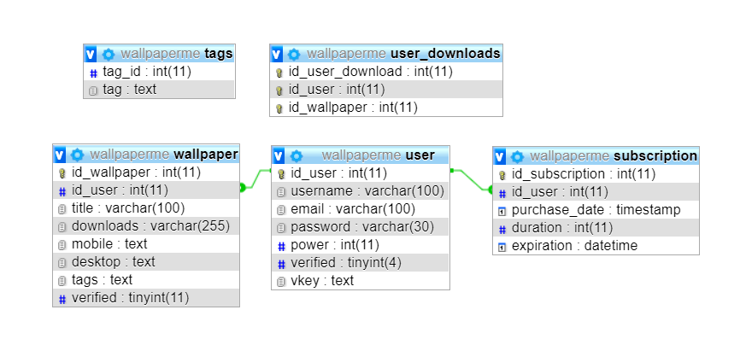

# OPIS FUNKCIONALNOSTI

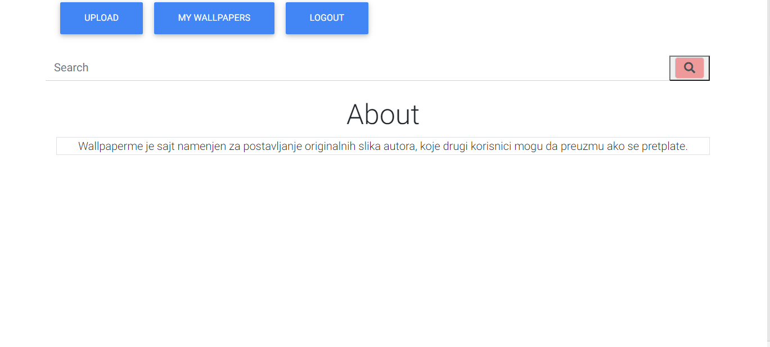

Ovo je prva stranica na koju korisnik dolazi, tu može da se uloguje, registruje ili da pretražuje slike.

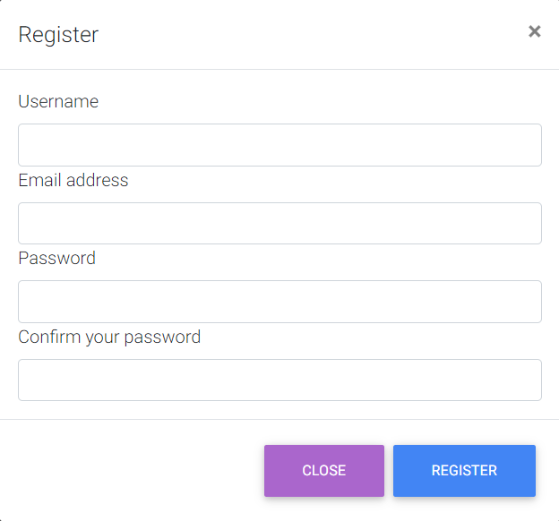

Izgled register forme

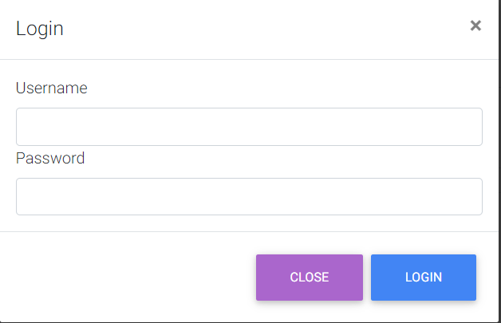

Izgled login forme

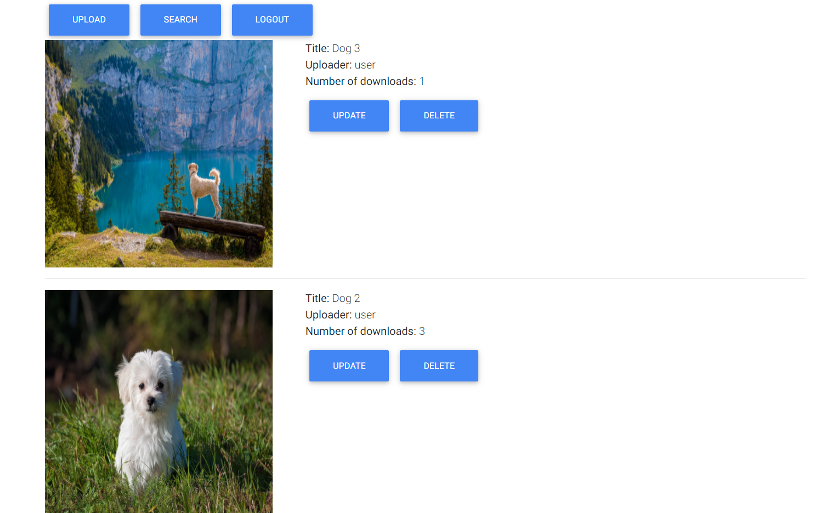

Kada korisnik klikne na my wallpapers, onda se prebaci na stranicu gde može da vidi svoje wallpapere što je upload-ovao i može da ih izmeni ili obriše.



Forma za upload wallpaper-a.

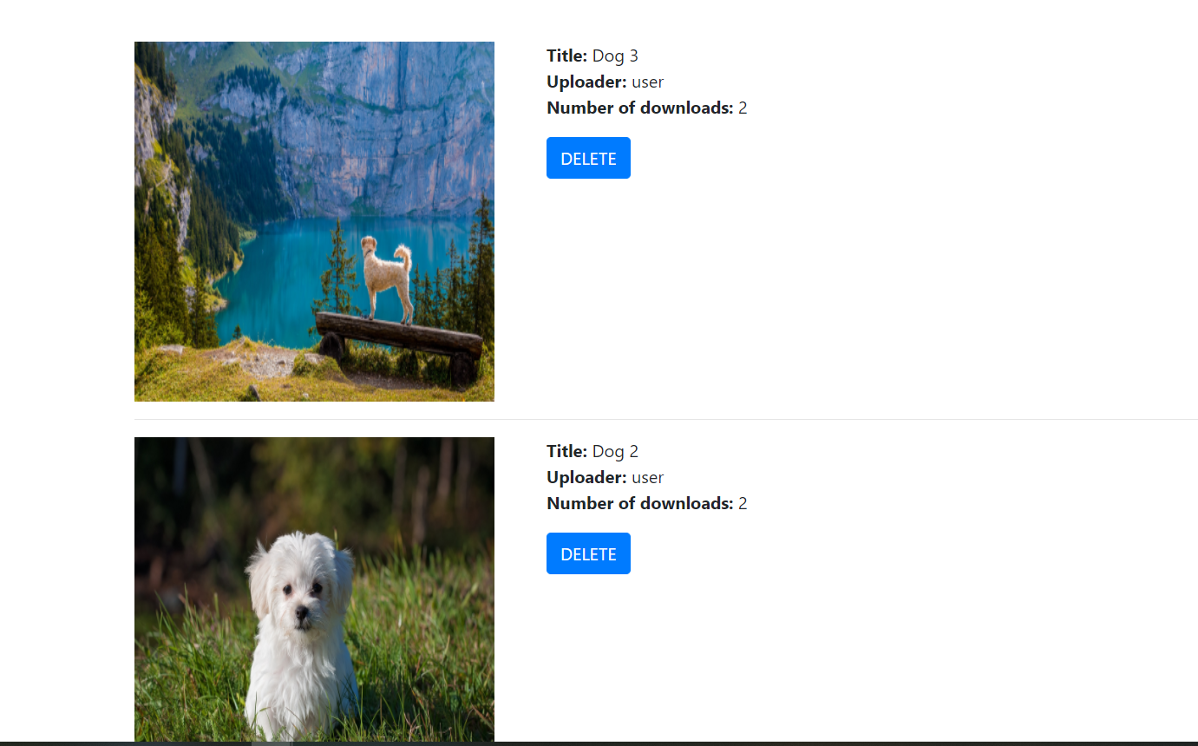

U admin delu, kojem može da pristupi samo admin, mogu da se brišu slike.

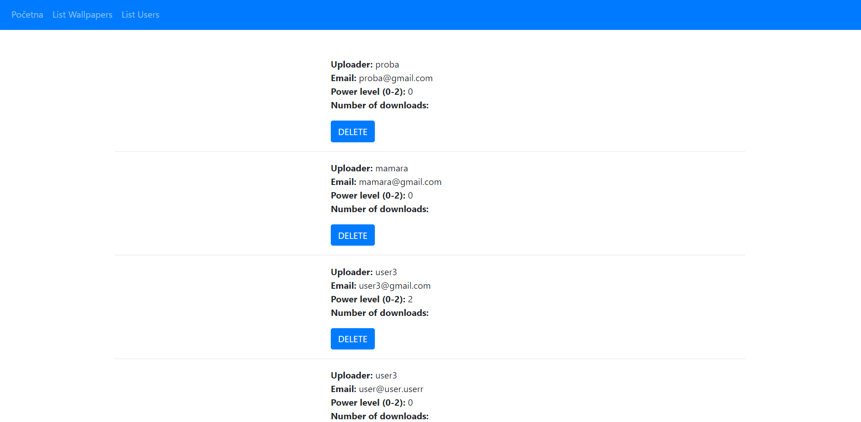

Isto tako, mogu da se brišu i useri iz baze u admin delu.

# KORIŠĆENA LITERATURA

1. <https://stackoverflow.com>
2. <https://getbootstrap.com>
3. <https://w3schools.com>
4. <https://php.net>